The Ch07_ConstructCo database stores data for a consulting company that tracks all charges to projects. The charges are based on the hours each employee works on each project. The structure and contents of the Ch07_ConstructCo database are shown in Figure P7.1.

Figure P7.1 Structure and contents of the Ch07_ConstructCo database

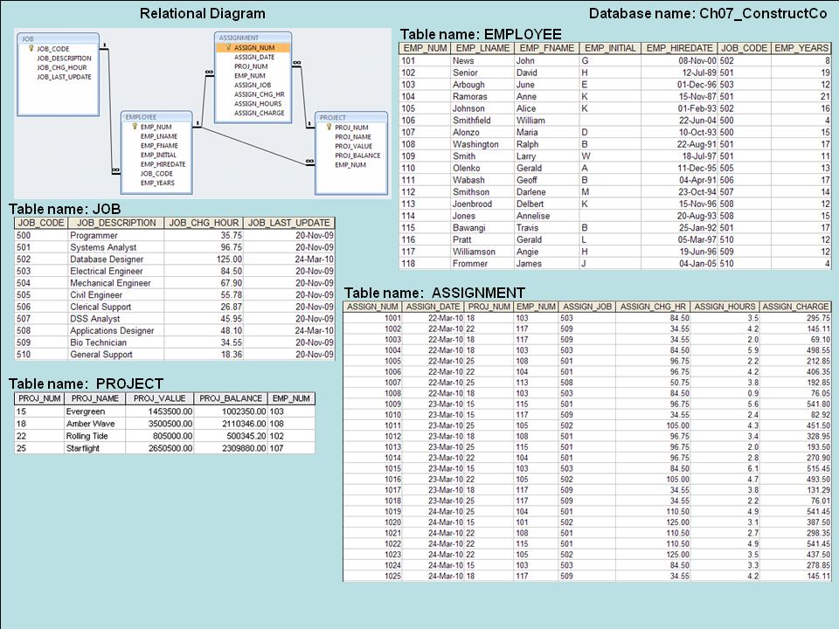

**Note that the ASSIGNMENT table in Figure P7.1 stores the JOB_CHG_HOUR values as an attribute (ASSIGN_CHG_HR) to maintain historical accuracy of the data. The JOB_CHG_HOUR values are likely to change over time. In fact, a JOB_CHG_HOUR change will be reflected in the ASSIGNMENT table. And, naturally, the employee primary job assignment might change, so the ASSIGN_JOB is also stored. Because those attributes are required to maintain the historical accuracy of the data, they are not redundant.**

**Given the structure and contents of the** Ch07_ConstructCo **database shown in Figure P7.1, use SQL commands to answer Problems 1–16**

1. **Write the SQL code that will create the table structure for a table named EMP_1. This table is a subset of the EMPLOYEE table. The basic EMP_1 table structure is summarized in the table below. (Note that the JOB_CODE is the FK to JOB.)**

|  |  |
| --- | --- |
| **ATTRIBUTE (FIELD) NAME** | **DATA DECLARATION** |
| EMP_NUM | CHAR(3) |
| EMP_LNAME | VARCHAR(15) |
| EMP_FNAME | VARCHAR(15) |
| EMP_INITIAL | CHAR(1) |
| EMP_HIREDATE | DATE |
| JOB_CODE | CHAR(3) |

- CREATE TABLE EMP_1 (

EMP_NUM CHAR(3) PRIMARY KEY,

EMP_LNAME VARCHAR(15) NOT NULL,

EMP_FNAME VARCHAR(15) NOT NULL,

EMP_INITIAL CHAR(1),

EMP_HIREDATE DATE,

JOB_CODE CHAR(3),

FOREIGN KEY (JOB_CODE) REFERENCES JOB);

1. **Having created the table structure in Problem 1, write the SQL code to enter the first two rows for the table shown in Figure P7.2.**

Figure P7.2 The contents of the EMP_1 table

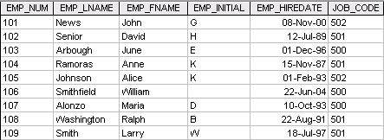

- INSERT INTO EMP_1 VALUES (‘101’, ‘News’, ‘John’, ‘G’, ’08-Nov-00’, ‘502’);

INSERT INTO EMP_1 VALUES (‘102’, ‘Senior’, ‘David’, ‘H’, ’12-Jul-89’, ‘501’);

1. **Assuming the data shown in the EMP_1 table have been entered, write the SQL code that will list all attributes for a job code of 502.**

**-** SELECT *

FROM EMP_1

WHERE JOB_CODE = ‘502’;

1. **Write the SQL code that will save the changes made to the EMP_1 table.**

**-** COMMIT;

1. **Write the SQL code to change the job code to 501 for the person whose employee number (EMP_NUM) is 107. After you have completed the task, examine the results, and then reset the job code to its original value.**

- UPDATE EMP_1

SET JOB_CODE = ‘501’

WHERE EMP_NUM = ‘107’;

To see the changes:

SELECT *

FROM EMP_1

WHERE EMP_NUM = ‘107’;

To reset, use

ROLLBACK;

1. **Write the SQL code to delete the row for the person named William Smithfield, who was hired on June 22, 2004, and whose job code classification is 500. (Hint: Use logical operators to include all of the information given in this problem.)**

**-** DELETE FROM EMP_1

WHERE EMP_LNAME = 'Smithfield'

AND EMP_FNAME = 'William'

AND EMP_HIREDATE = '22-June-04'

AND JOB_CODE = '500';

1. **Write the SQL code that will restore the data to its original status; that is, the table should contain the data that existed before you made the changes in Problems 5 and 6.**

**-** ROLLBACK;

1. **Write the SQL code to create a copy of EMP_1, naming the copy EMP_2. Then write the SQL code that will add the attributes EMP_PCT and PROJ_NUM to its structure. The EMP_PCT is the bonus percentage to be paid to each employee. The new attribute characteristics are:**

**EMP_PCTNUMBER(4,2)**

**PROJ_NUMCHAR(3)**

**(Note: If your SQL implementation allows it, you may use DECIMAL(4,2) rather than NUMBER(4,2).)**

- CREATE TABLE EMP_2 (

EMP_NUM CHAR(3) NOT NULL UNIQUE,

EMP_LNAME VARCHAR(15) NOT NULL,

EMP_FNAME VARCHAR(15) NOT NULL,

EMP_INITIAL CHAR(1),

EMP_HIREDATE DATE NOT NULL,

JOB_CODE CHAR(3) NOT NULL,

PRIMARY KEY (EMP_NUM),

FOREIGN KEY (JOB_CODE) REFERENCES JOB);

INSERT INTO EMP_2 SELECT * FROM EMP_1;

ALTER TABLE EMP_2

ADD (EMP_PCT NUMBER (4,2)),

ADD (PROJ_NUM CHAR(3));

1. **Write the SQL code to change the EMP_PCT value to 3.85 for the person whose employee number (EMP_NUM) is 103. Next, write the SQL command sequences to change the EMP_PCT values as shown in Figure P7.9.**

Figure P7.9 The contents of the EMP_2 table

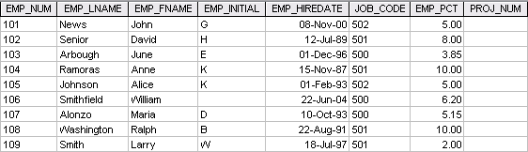

- UPDATE EMP_2

SET EMP_PCT = 3.85

WHERE EMP_NUM = '103';

To enter the remaining EMP_PCT values, use the following SQL statements:

UPDATE EMP_2

SET EMP_PCT = 5.00

WHERE EMP_NUM = ‘101’;

UPDATE EMP_2

SET EMP_PCT = 8.00

WHERE EMP_NUM = ‘102’;

1. **Using a single command sequence, write the SQL code that will change the project number (PROJ_NUM) to 18 for all employees whose job classification (JOB_CODE) is 500.**

**-** UPDATE EMP_2

SET PROJ_NUM = '18'

WHERE JOB_CODE = '500';

1. **Using a single command sequence, write the SQL code that will change the project number (PROJ_NUM) to 25 for all employees whose job classification (JOB_CODE) is 502 or higher. When you finish Problems 10 and 11, the EMP_2 table will contain the data shown in Figure P7.11. (You may assume that the table has been saved again at this point.)**

**-** UPDATE EMP_2

SET PROJ_NUM = '25'

WHERE JOB_CODE > = '502'

1. **Write the SQL code that will change the PROJ_NUM to 14 for those employees who were hired before January 1, 1994 and whose job code is at least 501. (You may assume that the table will be restored to its condition preceding this question.)**

**-** UPDATE EMP_2

SET PROJ_NUM = '14'

WHERE EMP_HIREDATE <= ' 01-Jan-94'

AND JOB_CODE >= '501';

1. **Write the two SQL command sequences required to:**
   1. **Create a temporary table named TEMP_1 whose structure is composed of the EMP_2 attributes EMP_NUM and EMP_PCT.**
   2. **Copy the matching EMP_2 values into the TEMP_1 table.**

-This solution contains answers for 13 a or b.

CREATE TABLE TEMP_1 AS SELECT EMP_NUM, EMP_PCT FROM EMP_2;

An alternate way would be to create the table and then, use an INSERT with a sub-select to populate the rows.

CRATE TABLE TEMP_1 AS (

EMP_NUM CHAR(3),

EMP_PCT NUMBER(4,2));

INSERT INTO TEMP_1

SELECT EMP_NUM, EMP_PCT FROM EMP_2;

1. **Write the SQL command that will delete the newly created TEMP_1 table from the database.**

**-** DROP TABLE TEMP_1;

1. **Write the SQL code required to list all employees whose last names start with Smith. In other words, the rows for both Smith and Smithfield should be included in the listing. Assume case sensitivity.**

**-** SELECT *

FROM EMP_2

WHERE EMP_LNAME LIKE 'Smith%';

1. **Using the EMPLOYEE, JOB, and PROJECT tables in the** Ch07_ConstructCo **database (see Figure P7.1), write the SQL code that will produce the results shown in Figure P7.16.**

* SELECT PROJ_NAME, PROJ_VALUE, PROJ_BALANCE, EMPLOYEE.EMP_LNAME,

EMP_FNAME, EMP_INITIAL, EMPLOYEE.JOB_CODE, JOB.JOB_DESCRIPTION,

JOB.JOB_CHG_HOUR

FROM PROJECT, EMPLOYEE, JOB

WHERE EMPLOYEE.EMP_NUM = PROJECT.EMP_NUM

AND JOB.JOB_CODE = EMPLOYEE.JOB_CODE;