Part 1:

Use the database shown in Figure P3.17 to answer Problems 17–23.

17. For each table, identify the primary key and the foreign key(s). If a table does not have a foreign key, write None.

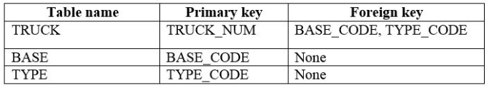

18. Do the tables exhibit entity integrity? Answer yes or no, and then explain your answer.

Yes,

The table exhibit entity integrity. The entire integrity ensure that the tables do not have duplicate data. It also ensures that the primary key which identifies each record with the table is unique and can not be null.

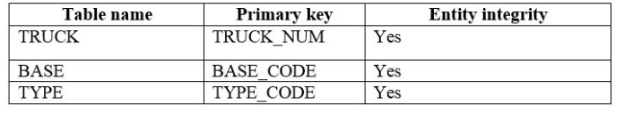

Here are three tables have unique primary key values. Therefore these three tables exhibit the entity integrity.

19. Do the tables exhibit referential integrity? Answer yes or no, and then explain your answer. Write NA (Not Applicable) if the table does not have a foreign key.

No, the table do not exhibit the referential integrity.

The table TRUCK exhibits the referential integrity. The referential integrity ensure that the foreign key must always reference an existing primary key or contain a null value. The foreign key of TRUCK table points to the existing primary key of the TYPE table.

The table BASE and TYPE does not have the foreign key values. Therefore, the tables do not exhibit referential integrity.

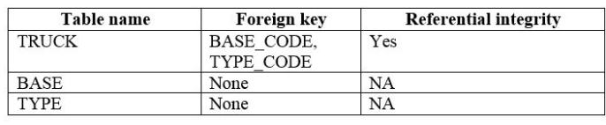

20. Identify the TRUCK table’s candidate key(s).

The candidate key of the TRUCK table is TRUCK_SERIAL_NUM

21. For each table, identify a superkey and a secondary key.

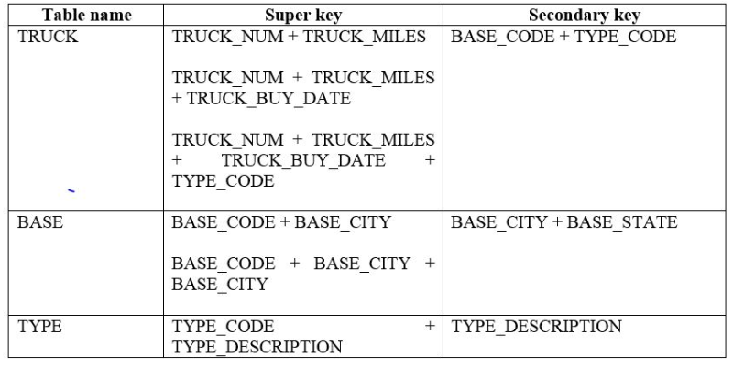

22. Create the ERD for this database.

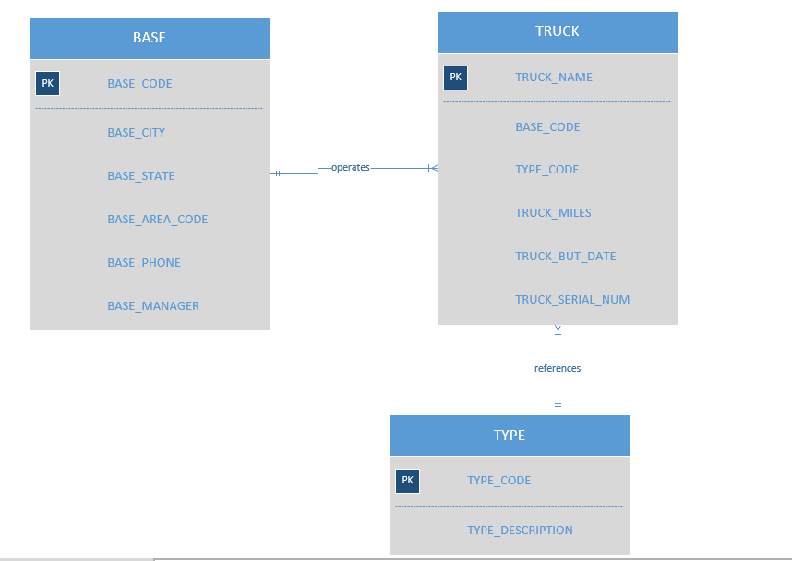

23. Create the relational diagram for this database.

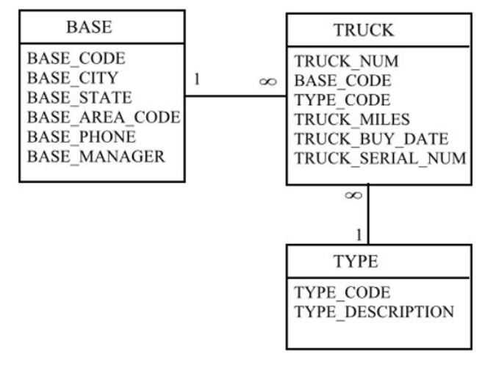

Part 2:

24. For each table, identify each of the following when possible:

a. The primary key

d. The foreign key(s)

e. A secondary key

25. Create the ERD. (Hint: Look at the table contents. You will discover that an AIRCRAFT can fly many CHARTER trips but that each CHARTER trip is flown by one AIRCRAFT, that a MODEL references many AIRCRAFT but that each AIRCRAFT references a single MODEL, and so on.)

26. Create the relational diagram.